CPIT240 – Lab project

Inventory Management System for Store

|  |  |
| --- | --- |
| NAME | ID |
| Ibrahim alqurshi | 2046430 |
| Moath mosleh alsolami | 1935160 |
| Omer saeed al-zahrani | 2046430 |
| Fahad Hamad alsifri | 1743998 |
| Abdullah justaniah | 2037017 |
| Section: ZR | |

Domain:

This Database project is about Managing Inventory for a particular Retail Store and Cover all the aspects of warehouses and it is information , as well it’s keep track and manages Customers and their Orders and Products ,Payments , and Stores records and all necessary information for management department ,who they budgeting the warehouse , in addition Mangers will manage Other Employees and warehouses.

Our database will store all information that related to employees and their Dependents , if employee is a manger ,he will manage one warehouse which he can access , add , delete , modify products and Supervise multiple employees in particular warehouse , and can add Supplier’s products ,Which will supply products on demand to more than one warehouse .The regular employees have access to current orders and process and fulfilling an opening orders.

Orders will be tracked and processed in the system by their unique order number , Order date, Status ,Total price are stored in the system. As well as the products are tracked in the system by their Unique product ID , each product has name , and price. In addition, products are store in warehouses which are identifiable by their unique warehouse IDs, capacity ,income , and expense is also stored in the database.

Customer can make Orders through the system, In due of New orders the data will be affected and will be modified accordingly. Products can be grouped in one order that made by the customer.

Income and Expense will be managed by management Department , Which have access this information to each warehouse , and they also can resupply whenever an Products goes out of stock.

Identify the entities and relationships:

1. **Managment Department:**

* Strong entity
* ID (primary kay)
* Expense
* Income

1. **Employee:**

* Strong entity
* EmpID (primary key)
* Name : Composite (Fname, Mname, Lname)
* SSN
* Phone
* Address
* Salary

1. **Dependent**

* Weak entity
* Name : composite (Fname,Lname)
* Phone

1. **Warehouse**

* Strong entity
* WhID
* Capacity

1. **Product**

* PID
* Pname
* Price

1. **Supplier**

* SID
* Sname
* Address
* Phone

1. **Customer**

* Name: composite (Fname,Mname,Lname)
* Address
* Phone (primary key)

1. **Order**

* OrderID (primary key)
* Date
* Status
* TotalPrice (Derived)

1. **Payment**

* Strong entity
* PaymentID (Primary key)
* Receipt
* Date
* PaymentType

**Relationships**

**- Relationship between Employee and Dependent:**

Each employee can have multiple dependent .

Each dependent Must have one employee.

**- Relationship between employee and employee:**

employee must have one supervisor.

employee can be supervisor.

**- Relationship between warehouse and employee:**

Each employee Must work for one warehouse.

One employee can be a manager for one warehouse.

Each warehouse must have one manager.

**- Relationship between warehouse and product:**

Each warehouse can have multiple products.

Each warehouse must have at least one product.

**-Relationship between warehouse and management Department:**

only one management department can have multiple warehouse.

Every warehouse must have only one management department.

**Relationship between Supplier and product:**

Each product must have at least one supplier.

Each supplier can have multiple products.

**- Relationship between product and order:**

Every product can be put in multiple orders.

Every order can have multiple products.

**- Relationship between customer and order:**

Each customer can have multiple orders

Each order must have one customer.

**- Relationship between payment and customer:**

Each customer can make multiple payment.

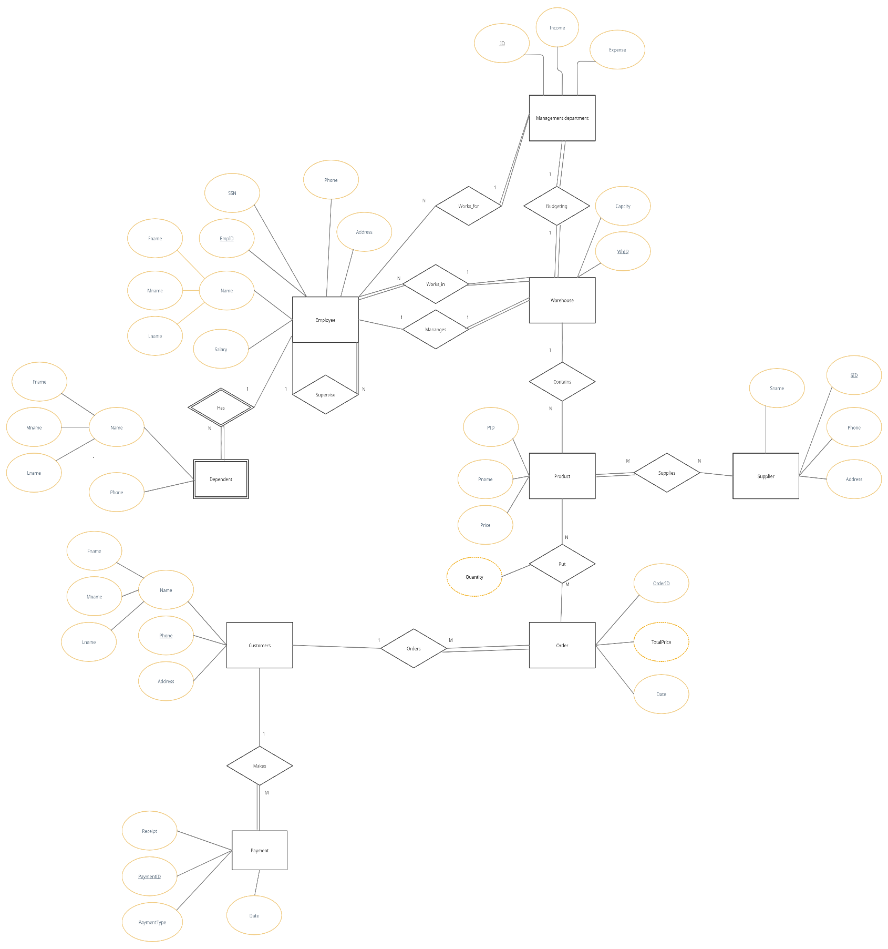ER DIAGRAM

10 possible queries

Adding raw with certain values to Employee

- insert into Employee values( 20001 , ‘ibrahim’ ,’ayman’ , ‘alqurshi’ , ‘157706123’, ‘Jeddah’ , ‘054994705’ , 10000);

Adding raw with certain values to Employee

- insert into Employee values( 20002 , ‘Omar’ ,’mohamed’ , ‘alzharani’ , ‘299847123’, ‘Jeddah’ , ‘0555355705’ , 9000);

Show empid from table employee.

-Select EmpID from Employee;

Show employee first name which their salary is bigger than 9000

-Select Fname from Employee where salary >9000;

Show all employees who their address exist in Jeddah

-Select * from Employee where address = ‘Jeddah’;

Show the first name of employees who their address exist in juddah and have a salary exceed 8000.

-Select Fname from Employee where Address = ‘Jeddah’ AND Salary > 8000;

Adding raw with certain values to product

-Insert into product values(1002 , ‘Vintage Hoodie M’ , 150 );

Adding raw with certain values to product

-Insert into product values(1011 , ‘Air Jordan Shoes 43’ , 400 );

Adding raw with certain values to product

-Insert into product values(10021 , ‘Vintage T-shirt M’ , 90 );

Change the product price of pid 10021 to 120

- update product price = 120 where PID = 10021;

Show customers table

- Describe Customer;

Select all rows from warhouse which has capacity less than 30

- select * from warehouse where capacity < 30;

Show warehouse

- Describe Warehouse;

Select all rows from management department which have income bigger than 10000 and Expense less than 90000

- Select * from management department where income > 10000 AND Expense < 9000;

SHOW Receipt and PaymentID from payment

- Select Receipt, PaymentID from payment;